**Project 2: Milestone 2**

**Personalized Book Recommendations Using User Reading Habits**

Surena Nokham

Department of Science & Technology, Bellevue University

DSC 680-T301: Applied Data Science

Amirfarrokh Iranitalab

July 14, 2024

**Business Problem**

The primary objective of this project is to enhance user experience on a book recommendation platform by providing personalized book suggestions based on individual reading histories and preferences. By leveraging advanced data science techniques, the goal is to increase user engagement and satisfaction through relevant and appealing book recommendations.

**Background/History**

Recommender systems are integral to modern digital platforms, from e-commerce websites to streaming services. In the context of book recommendations, utilizing user reading habits to suggest books can significantly enhance user satisfaction and engagement. Platforms such as Goodreads and Amazon employ complex algorithms to personalize user experiences based on their interactions with books. This project aims to develop a similar system, tailored to the specific needs of book readers.

**Data Explanation**

The datasets used in this project include the Goodreads and Book-Crossing datasets, which provide comprehensive information about books, user ratings, and reviews. The Goodreads dataset, available on Kaggle, contains details about books, user ratings, and reviews. Similarly, the Book-Crossing dataset, also available on Kaggle, includes user ratings and information about books and authors. Data preparation involved cleaning the datasets by handling missing values, removing duplicates, and standardizing text fields. Additionally, datasets were integrated to create a comprehensive dataset, and features were engineered based on user interactions, book metadata, and review content.

**Methods**

This project employs several data science methods to create a robust recommendation system. Collaborative filtering utilizes user-item interaction data to recommend books based on similar user preferences. Content-based filtering suggests books similar to those the user has read, based on attributes such as genre and author. Hybrid systems combine collaborative and content-based filtering to improve recommendation accuracy. Additionally, Natural Language Processing (NLP) techniques analyze user reviews and ratings to gain deeper insights into user preferences, enhancing the recommendation system's performance.

**Analysis**

Several visualizations were created to understand the data and derive insights. The distribution of ratings shows the overall user sentiment towards books. The top 10 most rated books highlight the most popular books based on the number of ratings. The average rating of the top 10 most rated books indicates the quality of these popular books. Visualization of the top 10 authors with the most books reveals the most prolific authors in the dataset. Lastly, the average rating by the top 10 authors reflects the reputation and quality of works by popular authors. These visualizations provide valuable insights into user preferences and guide the development of the recommendation system.

**Conclusion**

The analysis reveals significant trends in user preferences, underscoring the popularity of specific books and authors. These insights are crucial for developing a robust recommendation system that enhances user engagement by offering highly relevant book suggestions.

**Assumptions**

This project operates under the assumption that users' ratings and reviews accurately reflect their preferences and reading experiences. Additionally, it is assumed that the datasets used are representative of the broader user base and capture a wide range of reading behaviors and preferences.

**Limitations**

One of the primary limitations of this project is data sparsity, where some users have limited interaction data, which can impact the quality of recommendations. Another challenge is scalability, as managing and processing large volumes of data efficiently is crucial for the system's performance. Additionally, potential biases in the data could influence the recommendations, necessitating strategies to mitigate such biases.

**Challenges**

Key challenges faced in this project include ensuring consistency and accuracy when integrating data from different sources. Handling sparse data and making relevant recommendations for users with limited interaction history is also a significant challenge. Moreover, the system must be scalable to handle a large volume of users and books efficiently while maintaining performance.

**Future Uses/Additional Applications**

Future improvements can include incorporating additional data sources, such as social media interactions and purchase histories, to enhance personalization. Another potential application is adapting the recommendation system for other types of media, such as movies and music, leveraging similar data science techniques to provide personalized recommendations across different content types.

**Recommendations**

To improve user engagement, the recommendation system should leverage the popularity of top authors to attract new users and provide them with popular and highly rated books. Additionally, ensuring diversity in recommendations is essential to cater to various user preferences and avoid repetitive suggestions. Implementing a feedback loop where user feedback is continuously incorporated can also enhance the system's performance.

**Implementation Plan**

The implementation plan involves several key steps:

1. **Data Collection**: Gather data from multiple sources, including Goodreads and Book-Crossing datasets.
2. **Data Preparation**: Clean and integrate the datasets, handling missing values and standardizing text fields.
3. **Model Development**: Build and test collaborative, content-based, and hybrid recommendation models.
4. **Evaluation**: Assess model performance using metrics such as precision, recall, and F1-score.
5. **Deployment**: Implement the recommendation system on the platform, ensuring it is scalable and efficient.
6. **Monitoring**: Continuously monitor the system's performance and incorporate user feedback to refine the recommendations.

**Ethical Assessment**

Ensuring user data privacy and security is critical, with data being anonymized and securely stored. Bias mitigation strategies must be implemented to ensure fairness and diversity in recommendations. Additionally, it is essential to use data obtained with proper consent and comply with data protection regulations to maintain user trust and compliance with legal requirements.

**10 Questions**

1. How do you handle data sparsity in your recommendation system?
2. What strategies do you use to mitigate biases in recommendations?
3. How do you ensure the privacy and security of user data?
4. Can your system recommend newly released books with limited ratings?
5. How do you evaluate the effectiveness of your recommendation system?
6. What are the main challenges you faced during data integration?
7. How do you incorporate user feedback into the recommendation system?
8. What future improvements do you plan for the recommendation system?
9. How do you ensure the diversity of recommendations?
10. Can your system be adapted for other types of media (e.g., movies, music)?

**References**

Chen, L., Chen, G., & Wang, F. (2015). Recommender Systems Based on User Reviews: The State of the Art. Kowloon Tong, Hong Kong; Hong Kong RGC. Retrieved from [hkbu.edu.hk](https://www.comp.hkbu.edu.hk/~lichen/download/UMUAI15_Chen.pdf)

Kaggle Datasets: Goodreads, Book-Crossing, and Amazon Book Reviews.

Rocca, B., & Rocca, J. (2019). Introduction to Recommender Systems. Medium. Retrieved from [towardsdatascience.com](https://towardsdatascience.com/introduction-to-recommender-systems-6c66cf15ada)

**Appendix**

book_tags.csv

books.csv

ratings.csv

tags.csv

BX_Books.csv

BX-Book-Ratings.csv

BX-Users.csv

Visual #1

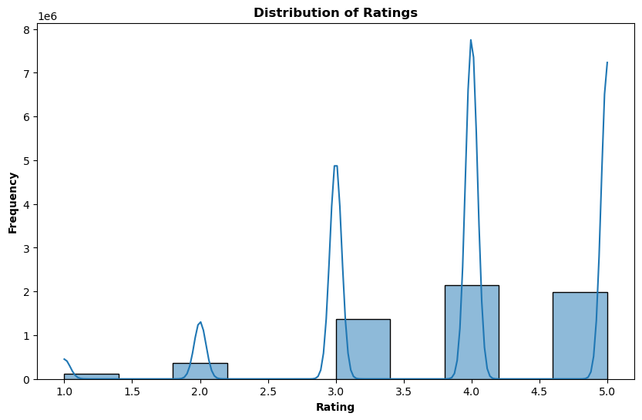

**Insight:** This visualization shows the overall distribution of user ratings. A higher concentration of ratings towards the higher end (e.g., 4 or 5 stars) indicates generally positive user sentiment towards the books in the dataset. Conversely, a higher concentration towards the lower end would suggest dissatisfaction. By examining the spread of ratings, we can assess the perceived quality of books. A normal distribution suggests balanced perception, while skewness towards higher ratings indicates a prevalence of high-quality books.

Visual #2

**Insight:** This visualization highlights the most popular books based on the number of ratings they received. Popular books are more likely to be known by a larger audience and can be used to identify trends in reading preferences. High engagement with these books suggests that they are widely read and discussed. This can inform recommendations by suggesting these popular books to new users or those with similar tastes.

Visual #3

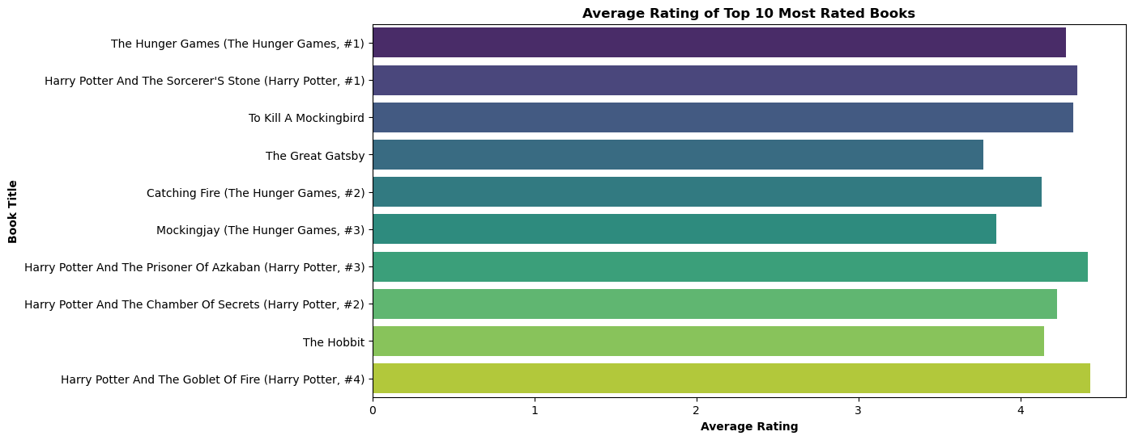

**Insight:** By comparing the average ratings of the most rated books, you can determine whether the most popular books are also highly rated. This can help identify books that are not only popular but also well-regarded by readers. Books with high average ratings indicate high reader satisfaction, suggesting that these books meet or exceed reader expectations.

Visual #4

**Insight:** By examining the average ratings of books by the top authors, you can gauge the overall reputation and quality of these authors' works. Authors with consistently high ratings are likely well-regarded and trusted by readers. Authors with high average ratings can be a basis for recommendations, suggesting their books to users who have enjoyed similar authors.

Visual #5

**Insight:** This visualization shows the most prolific authors in the dataset, i.e., those who have authored the most books. These authors are likely to have a significant influence on the dataset and reader preferences. Authors with many books might have a diverse range of works, appealing to various reader tastes. This can be useful in creating diverse recommendation lists.